Analysis Report

An analytical report of the data collected by our team from January to mid-February 2021 shows that the improvement plan to reduce patient time spent in the doctor's office worked successfully. The program is being implemented in the third week of this period.

The **Big Idea** of the project:

Every minute of life is priceless and will never be repeated. We will give each patient of the clinic more time for fun outside the clinic walls.

An analytical report is made using data visualizations. The main background for visualizations represents is a muted shade of blue. This color has a positive effect on the audience's subconscious and sets up a constructive result. Color combinations and the ratio of dark shades of brown show problem areas during implementing the project and emphasize more prosperous areas of its performance in a light color.

Next, let's take a closer look at each slide:

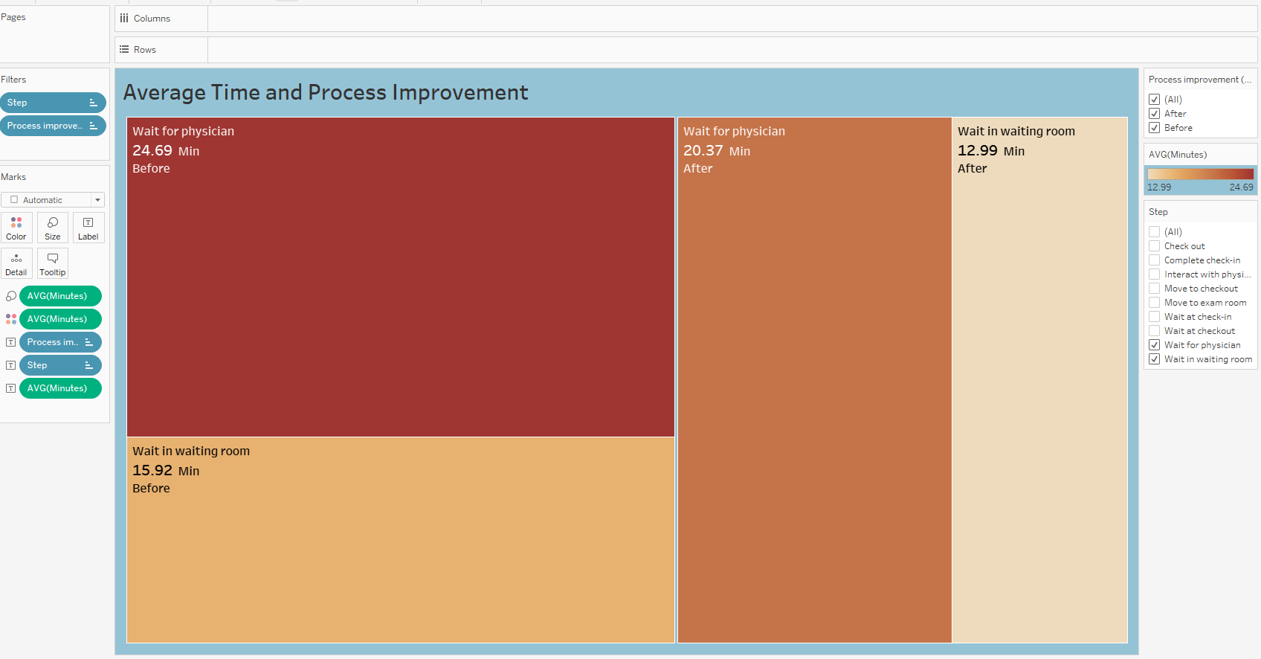

Data visualization "Average Time and Process Improvement" is a tree map built using such key indicators as quantitative measurements:

Average Wait Time in Minutes.

Steps of the Waiting Process.

And Non-numerical Improvement Process categories Before and After.

The visualization uses the Steps and Process Improvement filters.

The markers in the upper left corner of each rectangle show the Step name and the average time the patient spent at that stage and indicate the improvement process's state Before or After. This visualization shows that the average waiting time for a physician has been reduced by four minutes. We can also see that the average waiting room time has decreased by 3 minutes. These are the main stages in staying at a doctor's visit that patients are unhappy with. Additionally, using the filters used, we can display any stage of the patient's stay in the clinic and this stage's state in improvement before and after. Using this function, we will also see how the time has decreased or increased in each stage. Thus, this visualization allows us to demonstrate the successful team's work results to reduce the time at each stage of the patient's stay in the clinic for a specified period.

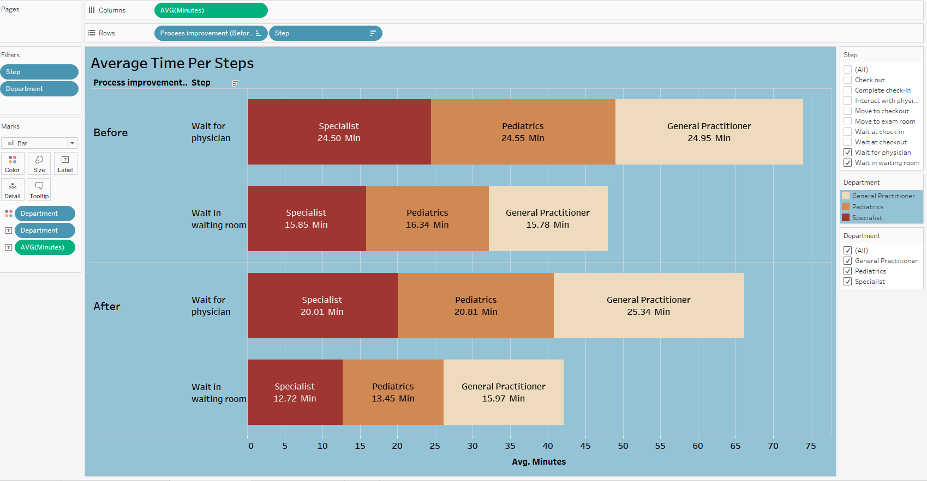

The next visualization is the “Average Time Per Step” by stages of the doctor's visit. This visualization reflects the average amount of time a patient spends in each department during the steps of a doctor's visit, such as waiting for a physician and time spent in the waiting room. Using the horizontal bar chart, we showed the history of time changes before and after reducing time. We can see that the patient's time in the department of Pediatrics and General Practitioner has been reduced by an average of 3-4 minutes. These indicators show us that reducing time spend in the doctor's office was carried out successfully in these departments. However, in the General Practitioner ward, the time increased by one minute.

This visualization allows us to determine which departments are the most successful in reducing the time before and after the improvement process. These data also let to see the proportion of time spent at a separate stage in the waiting room and at the step of waiting for a doctor. Thus, we see that the most successful improvements were implemented in the Specialist and Pediatric departments. The most unfavorable one is the General Practitioner department, where the patient's time increased by a minute. Based on this, we can conclude that there are improvements carried out successfully in most departments, but there are also lagging departments. The idea behind this visualization is to identify gaps in specific departments. It is necessary to prepare a specific plan to implement the reduction time now separately for the General Practitioner department.

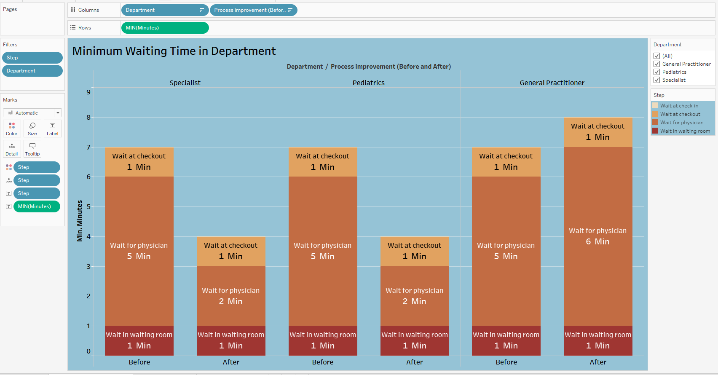

Visualization “Minimum Waiting Time by Department” is useful in that it reflects the minimum waiting time for patients at check-out and in the waiting, room is consistently minimum which is good. The minimum waiting time for a doctor in departments such as pediatrics and specialization has also been successfully reduced by three minutes. However, the waiting time for a doctor in the general practice department increased by a minute. Such visualization confirms that the minimum waiting time for the doctor has not been reduced in the GP department and that improvements are required.

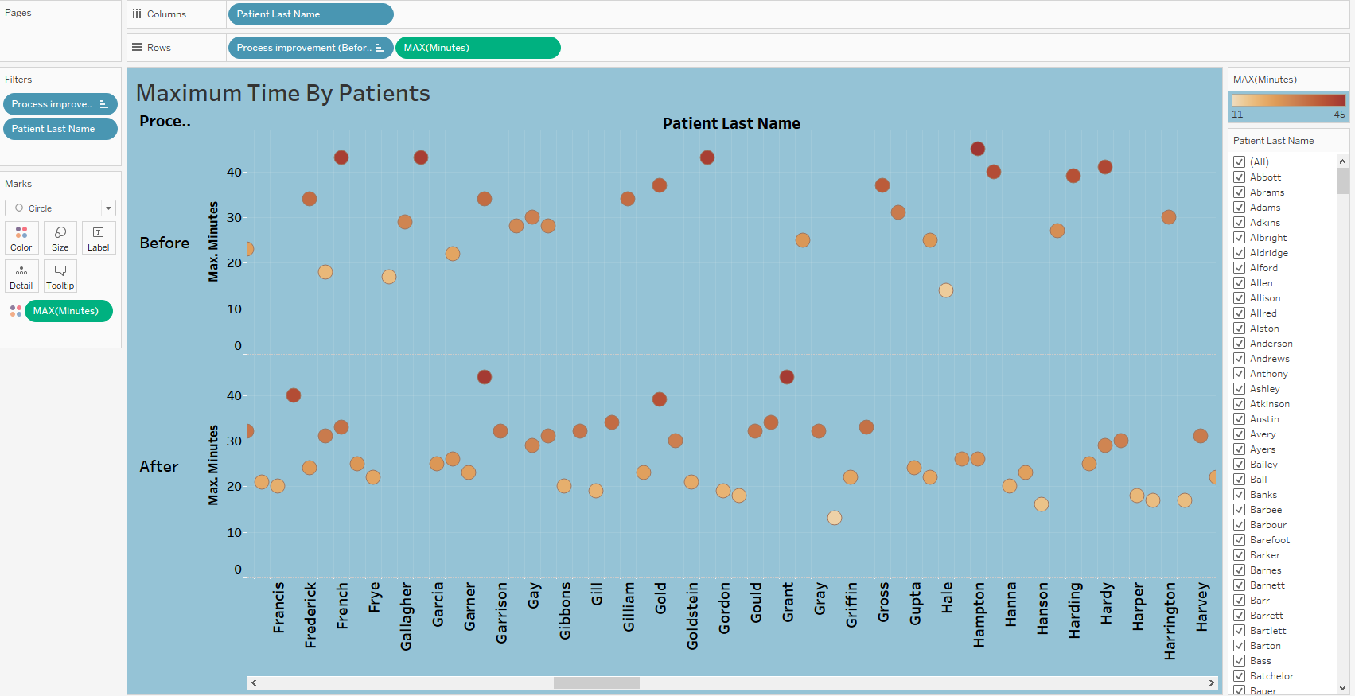

Visualization of the “Maximum Time By Patients” makes it possible to see that the number of people who spent more than forty minutes waiting is much less after the improvements have taken place. Before modification, 12 people spent more than 40 minutes waiting for a doctor. However, after the improvement in time passed, there were only four such patients. In this visualization, dark brown dots represent a sample number of patients who have spent more than forty minutes waiting. Also, in the range from 10 to 20 minutes, 12 patients are indicated by light dots that spent less than 20 minutes waiting for a doctor after improvement. There were only three such patients before the process of reducing the time. Thus, this visualization demonstrates to us the successful implementation of a project to reduce patients waiting for a doctor.